Included herewith is a link to an article published by Hemmings Motor News on British Invasion 2024.
https://www.hemmings.com/stories/mgs-rolls-royces-and-much-more-at-the-32nd-british-invasion/
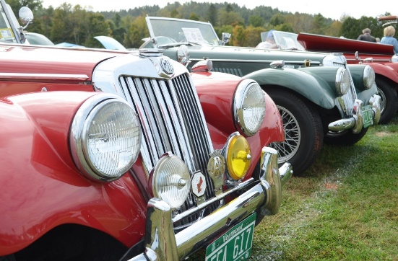 | MGs, Rolls-Royces, and Much More at the 33rd British Invasion  Founded in 1990 over a pint of ale in Stowe, Vermont, as the legend has it, the British Invasion is one of the largest all-British car shows in the U.S. The event, held this year from September 20-22, begins with a Friday evening block party and informal car show in downtown Stowe, and ends on Sunday after a tailgate picnic competition and a “Competition of Colors,” in which cars are ...  www.hemmings.com
There are lots of photos of the Event by Year on our Website "www.britishinvasion.com"
The Winners report for the British Classic Motorcar Show (People's Choice competition with 60+ separate classes) also lists the home town of the Class Winners.
Attendess travel long distancees to particiapte in the British Invasion Weekend.

